## NAME:S.Logitha

## REG NO:192121138

**15.USING RAPTOR – SWAP TWO CHARACTER**

**FLOW CHART**

**FLOW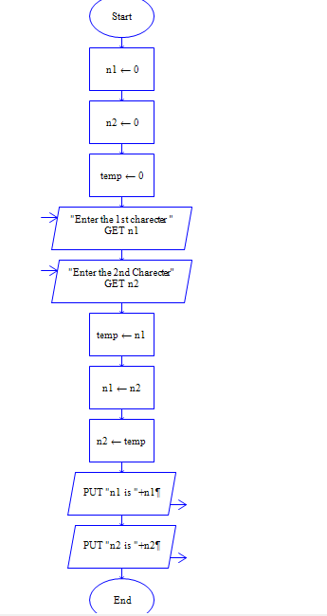CHART**

**OUTPUT**

INPUT

N1 =V

N2 = R

